1) write a c program to print hello world

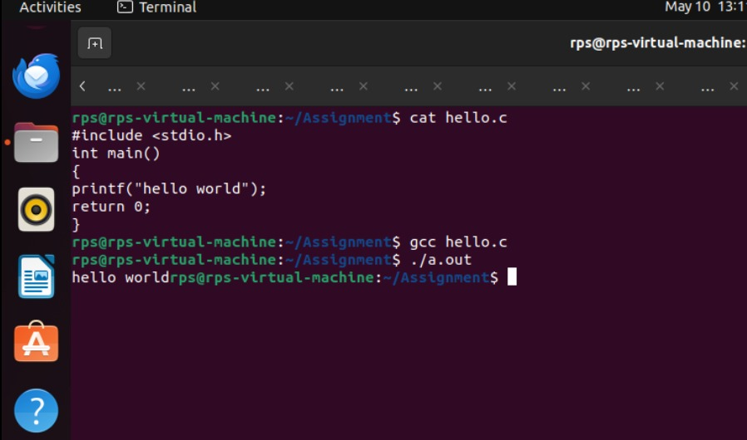

2) Write a c program to print adding of two numbers

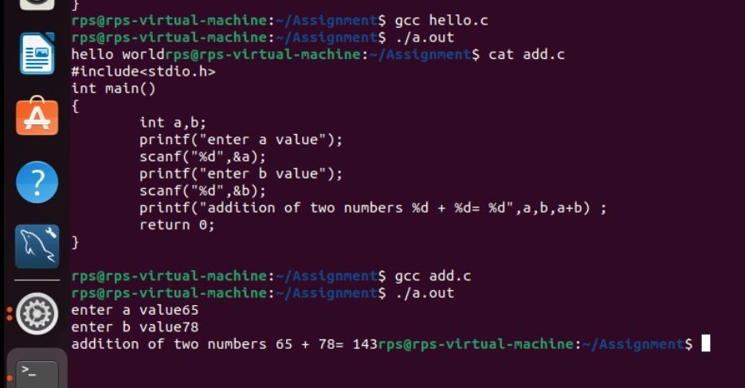

3)Write a c program to print date and time

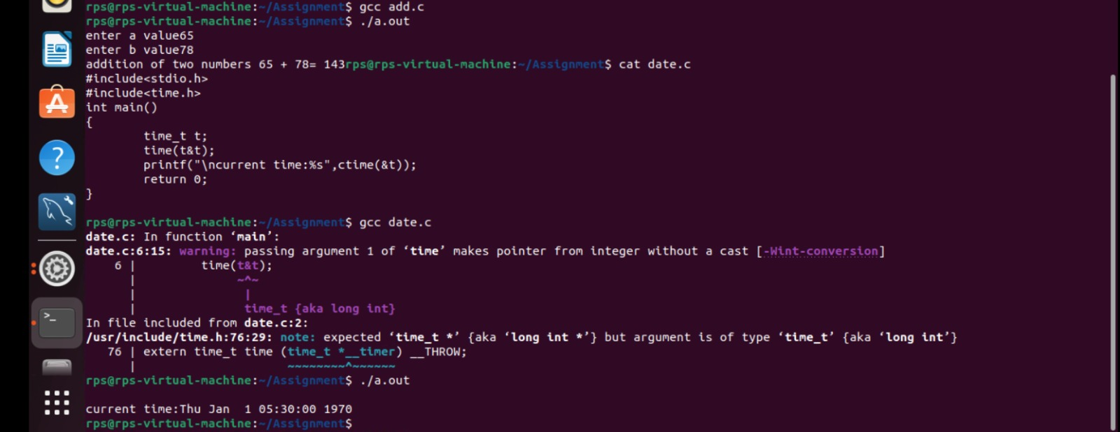

4)Write a c program to take input from user to enter their name on the screen

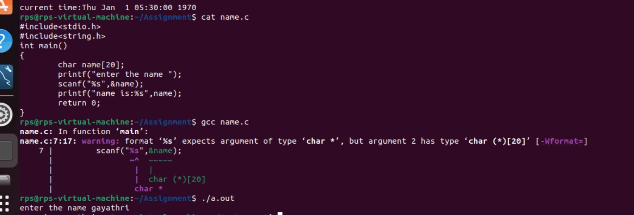

5)Write a c program to find a given number is even or odd

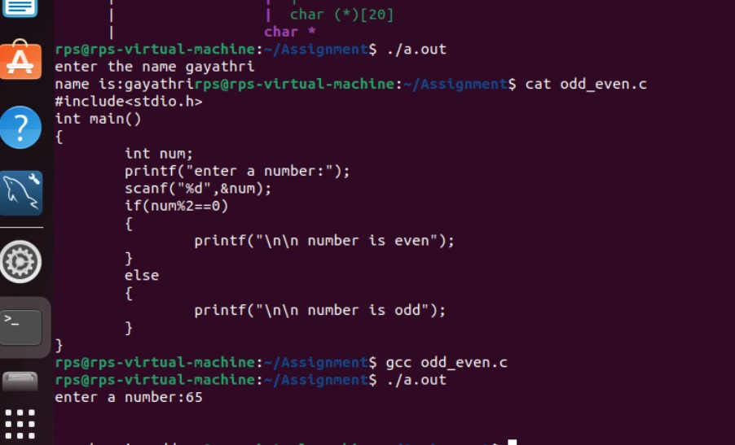

6)Write a c program to print reverse num

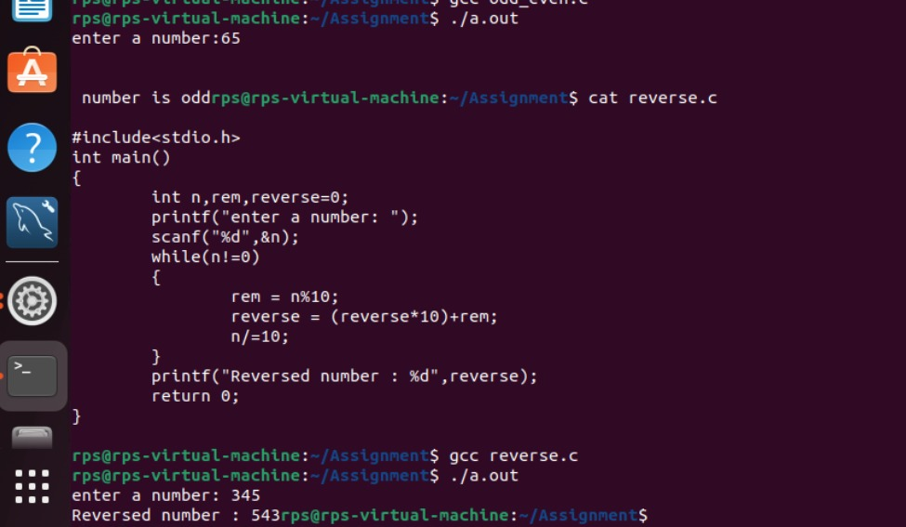

7)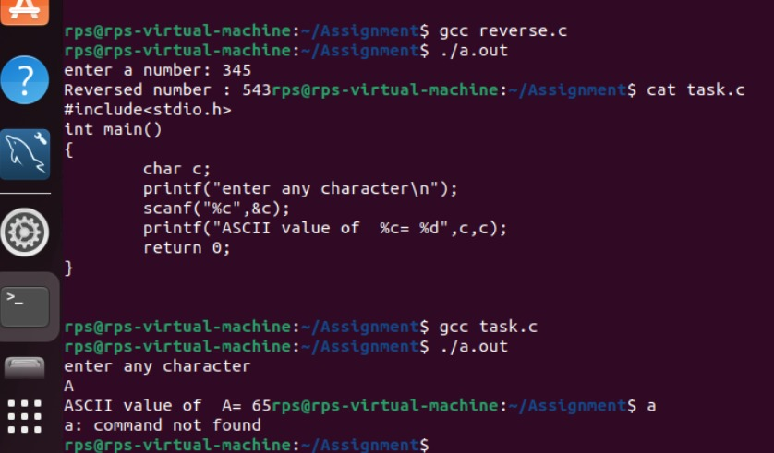

8)Write a c program to find the size of variables

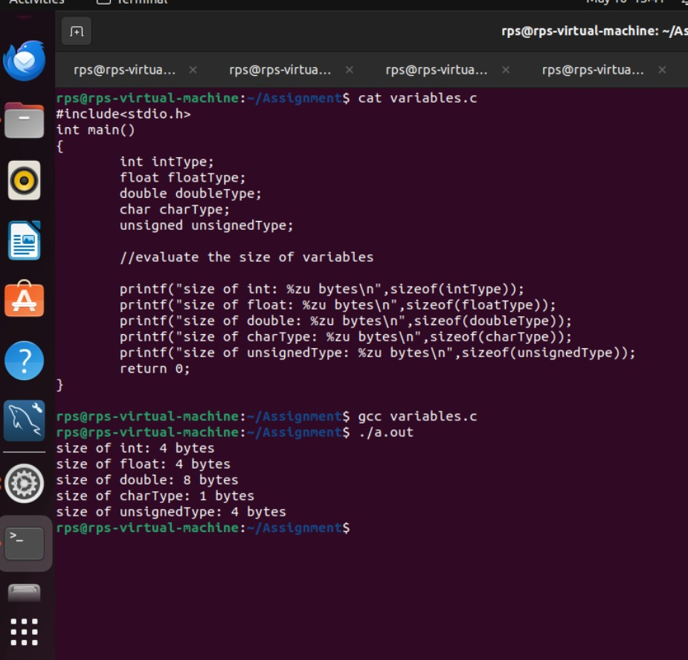

9)Write a c program to find quotient,remainder,dd,dv

